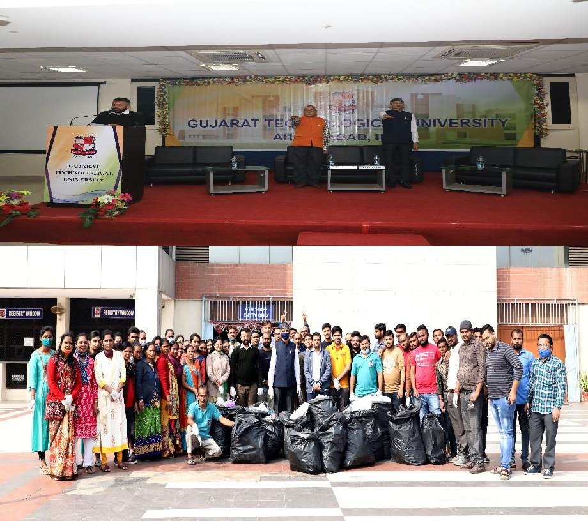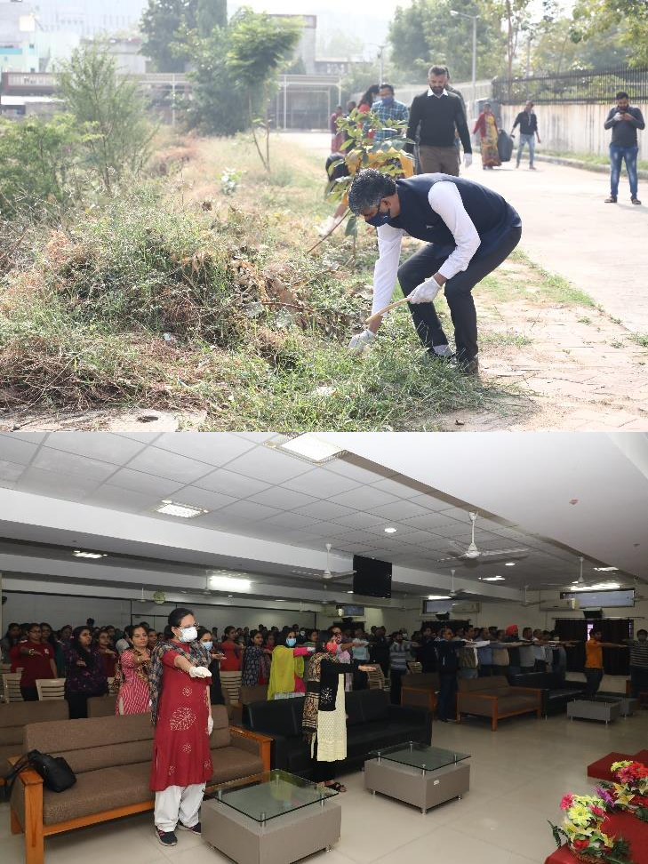Plastic Free Campus Drive on dated 4/12/2021

GTU Sports Section has organized Plastic Free Campus drive on dated 4/12/2021.More than 350 Staff, Faculty and Student were enthustastically participated total No. of 224 GTU PG School’s students also participated in this event.
in Plastic Free Campus Drive..More than 140 kg plastis were collected from GTU Chandkheda Campus and Various Zones of GTU.All Present Staff,Faculty and Students were taking a Pledge “Not to Use Plastic”.

